TOWARDS THE QUESTION OF RAILWAYS’ DEVELOPMENT IN THE PRINCIPALITY OF BULGARIA

Ivan Ivanov
University of Transportation, Sofia, Bulgaria

Abstract. Based on the Central State Archives (CSA) and Ruse’s Archives’ data, we analyze the state of railways transport between the 19th and 20th centuries’ Principality of Bulgaria. Its underdevelopment and insufficiency are justified. It is established that its condition during the examined period hinders the country’s economic development and negatively impacts on the development of sea and river transport. The different Bulgarian governments have established the latter and are trying to overcome the problem by renovating the locomotive fleet.
Keywords: history of Bulgarian transportation system; Bulgarian governments; railway transport

Main text – example
The Bulgarian transportation system’s history from the 19th century has been a research interest to both Bulgarian and foreign researchers (Roberts, 2019, pp. 33-34). The main research interest is primarily on the construction of ports and railway stations, carried out at the beginning of the last century¹. Even in the period between the world wars, researchers inquire on…

1. Principality’s transportation system’s characteristics
Until now, the development of the Principality’s transportation system (Fig. 1) for the researched period has been reconstructed through the Central State Archive’s data and partially through Russe and Plovdiv’s State Archives (Yalin, 2016).

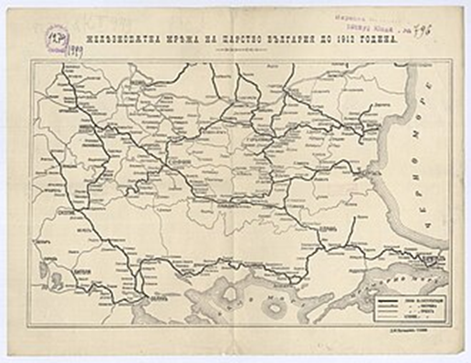
Figure 1. Title

The stated one-sidedness of historical reconstruction has been noticed by modern researchers (Gogov et al., 2018). A significant and complex highlight of the problem was the discovery of Vidin’s State Archive (VSA) and State Military Historical Archive (SMHA)², which…

2. Development of railway transport through renovation of locomotive fleet and railway bridges’ construction
In an article, Jivko Egov is the first to point out the importance of the information provided by the newly opened funds of VSA. He especially considers the documents highlighting the renewal stages of the locomotive fleet (Egov, 2020, p. 19) and the quality training in the Railway School that opened at the beginning of the last century. The article pays special attention to the analysis of the curriculum (Tabl. 1), which was first published by Yavor Popov (Popov, 2017, p. 28)…
Table 1. Title
Column | Column
Text | Text

Conclusions and summary
As a result of the inspection of the newly opened funds in the VSA and SMHA, the visible modernization of the locomotive fleet was established. The latter allowed a new reading of railway's transport development in the Principality of Bulgaria from the end of the 19th century and the beginning of the 20th century.

Acknowledgement and Funding
The work was supported and funded by […], [grant number XXX]
The author would like to acknowledge the employees at the VSA and SMHA for their assistance in working with the archives.

NOTES
- Transport association. History of Bulgarian transport. https://www.BDZ.ORG/gg#-old. [Viewed 2019-11-17].
- State military historical archive. https://www.military.com/2019/12/11/Echo=15764514. [Viewed 2019-3-11].

REFERENCES
Gogov, M., Petrov, M. & Getov, R. (2018). History of the Bulgarian railways. Academ. [In Bulgarian]
Egov, J. (2020). The railway bridges of the Principality. Istoriya-History, 28(3), 13 - 19. [In Bulgarian]
Popov, L. (2017). The curriculum of the Railway School. In: P. Ivanov (еd.). History of the Railway School (pp. 23-29). LLRR. [In Bulgarian]
Roberts, P. (2019). Bulgarian railway stations. Hiperboreea, 8(2), 33 - 49. https://doi.org/10.1515/opphil-2019-0029.
Yalin, B. (2016). Development of the transport in Bulgaria. [Doctoral dissertation. Virtual Institute]. Kardam-Thesis. https://www.kardam/winter-news/2018/12/1157614. [In Bulgarian]

Prof. Ivan Ivanov, DSc.
ORCID iD: 0000-0001-7541-162X
Web of Science Researcher ID: Y-2942-2007
Transport University
Sofia, Bulgaria
E-mail: i.ivanov@uwe.bg

